Board Game 0

Team Members:

* Joseph Morzuch
* Kyle Harris

Software Design Description

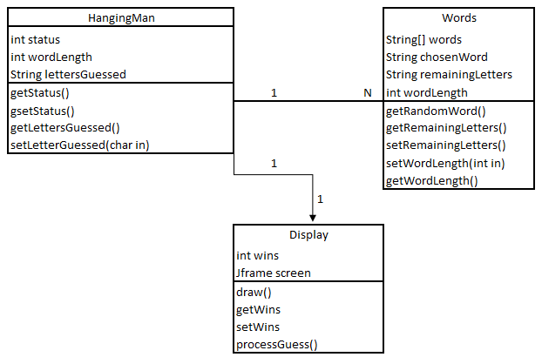

Kyle Harris will be coding the Words() class and partner with Joe on the Display() class

Joseph Morzuch will be coding the HangingMan() and partner with Kyle on the Display() class